**Barron’s Let’s Review Regents – Algebra II**

# Chapter 9: Probability

## 9.1 Sample Spaces

**Key Ideas**

A *sample space* is a list of all possible *outcomes* of some experiment. When it is possible to create an accurate sample space, calculating the *probability* of different types of outcomes can be found by counting. The probability of something happening can range from as low as 0% = 0.00 (if it is impossible) to as high as 100% = 1.00 (if it must happen). Most probabilities are somewhere between 0 and 1.

When a fair coin is flipped, there are two possible outcomes: heads and tails. Since each outcome is equally likely, the two outcomes can be written as a set called the sample space.

{ Heads, Tails }

Anything you can try to calculate the probability of is known as an *event*. The sample space can be used to calculate the probability of different events that can happen with the coin.

To calculate the probability of the coin landing on heads, first count the number of possible outcomes in the sample space. Make that the denominator in your answer. Then count the number of *favorable* outcomes, meaning outcomes in the sample space that are heads. Make that the numerator of your answer. Since there are 2 possible outcomes and 1 outcome with heads, the probability of the coin landing on heads is .

**Math Facts**

If there is a sample space, the probability of some event happening can be calculated with the fraction .

Below is a picture of a circle divided into 6 equal slices, numbered 1 through 6. A spinner is put into the middle and spun.

The sample space for one spin is { 1, 2, 3, 4, 5, 6 }.

With this sample space, various question can be answered.

**Basic Probability Questions**

The most basic question is one like: What is the probability that the spinner will land on the number 4? This question is abbreviated as P(4).

Since there is one 4 in the sample space and there are 6 total numbers in the sample space, .

**Probability Questions Involving the Word “Not”**

If the question is to find the probability that the spinner will not land on the number 4, or P(not 4), count the number of outcomes in the sample space that are not 4. Since 5 of the numbers in the sample space are not the number 4, .

**Probability Questions Involving the Word “And”**

Questions involving the word “and” require you to analyze each element in the sample space to see if it meets two different conditions. Here’s a typical question involving the spinner with 6 equal slices, numbered 1 through 6.

“On one spin, what is the probability that the spinner will land on a number that is greater than 3 and even, or (P greater than 3 and even)?”

The denominator of the solution is still 6. For the number, examine all 6 numbers in the sample space to see how many of them are both greater than 3 and also even.

Exactly two of the numbers, 4 and 6, satisfy both conditions. So the numerator of the probability fraction is 2, and the solution is .

**Probability questions Involving the Word “Or”**

Imagine there is a game where you spin the spinner and you win a prize if the spinner lands on an even number or on a number that is greater than 3. To find the probability of winning this game, go through the 6 outcomes to find how many of them are either even, greater than 3, or both.

Of the 6 numbers, the numbers 2,4, 5 and 6 all are either even, greater than 3, or both. The probability of getting a number that is even or greater than 3 is .

Probability Questions Involving the Word “Given”

Imagine the spinner is spun. Somebody looks at it before you get a chance to and tells you a hint about the number it landed on, such as “It landed on an even number.” Then a question is asked like, “What is the probability that it landed on a number greater than 3?” Had you not known about the hint, the solution would since 3 of the 6 numbers (4, 5 and 6) are greater than 3. With the hint, though, you can get a more accurate answer.

This question could be described as “What is the probability of getting a number greater than 3 given that it landed on an even number?” or . You can instead use the given symbol, |, to write .

**Example 1**

A fair coin is flipped, and a fair 6-sided die is rolled. The sample space has 12 outcomes { H1, H2, H3, H4, H5, H6, T1, T2, T3, T4, T5, T6 }. Using this sample space, calculate the probability of getting:

A) An outcome with tails on the coin

B) An outcome with tails on the coin and 2 on the die

C) An outcome with tails on the coin or 2 on the die

D) An outcome with tails on the coin given that there is a 2 on the die.

E) An outcome with a 2 on the die given that there is a tails on the coin

*Solution*:

A) Since 6 out of the 12 outcomes have a T in them, the probability is .

B) Only one of the 12 outcomes has a T and a 2, so the probability is .

C) The outcomes H2, T1, T2, T3, T4, T5, T6 each have a 2 or a T (T2 has both). This is 7 out of the 12 outcomes in the sample space, so the probability is .

D) Since it is given that 2 is on the die, the sample space gets reduced to {H2, T2}. Only one of the two outcomes has a T, so the probability is .

E) Since it is given that tails is on the coin, the sample space set gets reduced to {T1, T2, T3, T4, T5, T6}. Of the 6 possible outcomes in this reduced sample space, only one has a 2 on the die. So the probability is .

**Sample Spaces Represented as Tables**

For certain surveys, the results can be represented in a table. This table can serve as a sample space for probability questions.

Imagine that 100 people are surveyed and asked two questions “Are you more than 14 years old?” and “Are you more than 5 feet fall?” The results of the survey can be shown with a table like this.

|  |  |  |  |
| --- | --- | --- | --- |
|  | **Under 14 Years** | **Over 14 Years** | **Total** |
| Under 5 feet | 21 | 12 | 33 |
| Over 5 feet | 9 | 58 | 67 |
| Total | 30 | 70 | 100 |

A probability question that can be answered with this table is “If one person is taken from the 100 at random, hat is the probability the person will be both under 14 years old and over 5 feet tall?”

The denominator of the fraction will be 100 since there are 100 people in total. For the numerator, the number of people who are both under 14 years old and over 5 feet tall, based on the information in the table, who are both under 14 years old and over 5 feet tall, based on information in the table, is 9.

So, the solution is .

**Example 2**

Using the above table, what is the probability that a randomly chosen person will be under 14 years old?

*Solution*: The denominator of the solution is 100. The numerator is since there are 21 people under 14 years old who are under 5 feet tall and 9 people under 14 years old who are over 5 feet tall. The solution is .

**Example 3**

Using the above table, find the probability that a randomly chosen person is over 5 feet tall or over 14 years old.

Solution: The total number of people is 100, which will be the denominator for the solution. For the numerator, look at the four possibilities and which count people who are either over 5 feet tall, over 14 years old, or both. Three of the four possibilities have at least one of those characteristics. The only one that doesn’t is the people are both under 14 years old and 5 feet tall. Add , and make that the numerator. The solution is .

**Example 4**

Using the above table, find the probability of a randomly chosen person being over 5 feet tall given that the person is over 14 years old.

Solution: Because of the word “given,” the denominator of the fraction is no longer going to be 100. Since it is known that the person is over 14 years old, the 30 people under 14 years old are no longer relevant. The number of people over 14 years old is 70, and this will be the denominator of the solution. Of those 70 people, 58 of them are over 5 feet tall. So the solution is .

**Sample Spaces Represented as Venn Diagrams**

Another way to represent the data from the age/height survey is with a Venn diagram.

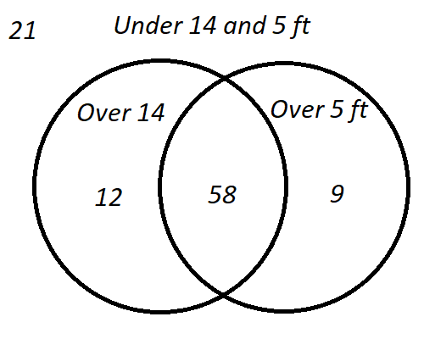

The two circles represent the people who are over 14 years old and the people who are over 5 feet tall. Just as there are four different categories of people in the table (both under 14 and under 5 feet, under 14 but over 5 feet, over 14 but under 5 feet, and both over 14 and over 5 feet), this Venn diagram has 4 regions (in neither circle, in the circle on the left, but not in the circle on the right, in the circle on the right but not in the circle on the left, and in both circles.

Use the Ven diagram to answer a question like “If a person is chosen randomly from the 100 surveyed, what is the probability that the person is under 14 years old but over 5 feet tall?” The circle on the right represents people who are over 5 feet tall. This is composed of the 58, which are the people who are both over 5 feet and over 14 years old, and of the 9, which are people who are over 5 feet but not over 14 years old (since they are not inside the over 14 years old circle on the right). The solution is .

**Example 5**

The Venn diagram below is based on two survey questions “Do you like frozen yogurt?” and “Do you like mustard?”

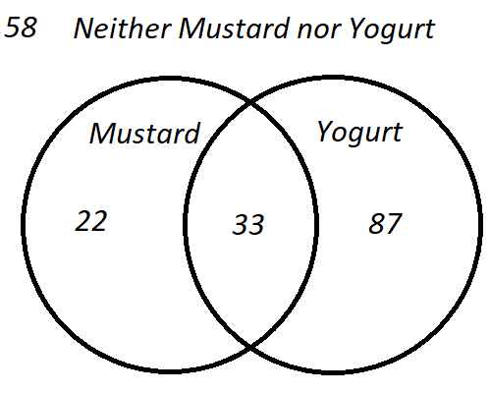

Use this Venn diagram to answer the following questions:

A) What is the probability that a person chosen randomly among those surveyed likes frozen yogurt but does not like mustard?

B) What is the probability that a person chosen randomly among those surveyed likes mustard?

C) Given that a randomly person likes mustard, what is the probability that the person also likes frozen yogurt?

*Solution*:

There are people in the survey.

A) The number of people who like yogurt is 87 but not mustard out of 200 people. The solution is .

B) There are people who like mustard out of 200 people. So the solution is .

C) Since it is given that the person likes mustard, the denominator is the number of people who like mustard (. The number of people who like mustard and yogurt is the intersection of the Venn diagram which has 33 people. The solution is then .

### Check Your Understanding of Section 9.1

1. *Multiple-Choice*
2. If a fair penny and a fair dime are flipped, the sample space of possible outcomes is {HH, HT, TH, TT}. What is the probability of getting tails on both coins?  
   {TT}  
   **(2)**
3. A fair 6-sided die is rolled. The sample space is {1, 2, 3, 4, 5, 6}. What is the probability that the number that comes up is both even and greater than 4?  
   **(1)**
4. A spinner with equal size sections and with the number 1 to 8 on it is spun. The sample space is {1, 2, 3, 4, 5, 6, 7, 8}. What is the probability that the number on the spinner is either even or greater than 5?  
   Sample Space {2, 4, 6, 7, 8}.  
   **(4)**
5. A fair coin is tossed, and a fair 6-sided die is rolled. The sample space of possible outcomes is {H1, H2, H3, H4, H5, H6, T1, T2, T3, T4, T5, T6}. If it is known that the die landed on a number greater than 4, what is the probability that the coin landed on heads?  
   Sample Space: {H5, H6, T5, T6}  
   **(1)**

**Questions 5, 6 and 7 use the following information:**

40 people are surveyed about whether they like iOS or Android. The results are collected on this table.

|  |  |  |  |
| --- | --- | --- | --- |
|  | **Like Android** | **Don’t Like Android** | **Total** |
| Like iOS | 7 | 20 | 27 |
| Don’t like iOS | 12 | 1 | 13 |
| Total | 19 | 21 | 40 |

1. If one of the 40 people is selected at random, what is the probability that the person likes both iOS and Android?  
   **(2)**
2. What is the probability that a randomly selected person likes Android if it is known that the person likes iOS?  
   **(1)**
3. What is the probability that a randomly selected person likes either iOS or Android?  
   **(1)**

**Questions 8, 9 and 10 use the following information**

50 students are surveyed about how they like the red and blue Barron’s books. The results are collected on this Venn diagram.

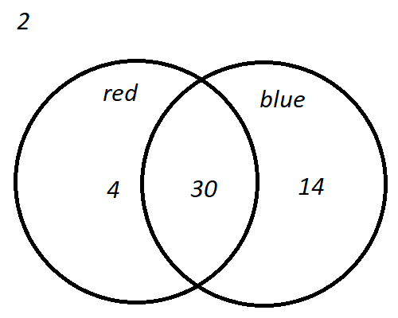

1. What is the probability that a randomly selected person likes both the red and the blue book?  
   **(4) .60**
2. What is the probability that a randomly chosen person will not like the blue book?  
   **(2) .12**
3. From the group of people who like the red book, a person is randomly chosen. What is the probability that the person also likes the blue book?  
   Likes the red book:   
   Likes the red book and also the blue book: 30  
   **(3) .88**
4. *Show how you arrived at your answers*.
5. A fair 6-sided die with the faces numbered 1 to 6 is rolled. A spinner with the letters, A, B and C, with equal chances of occurring, is spun. What is the sample space of possible outcomes?  
   **{ 1A, 2A, 3A, 4A, 5A, 6A, 1B, 2B, 3B, 4B, 5B, 6B, 1C, 2C, 3C, 4C, 5C, 6C}**
6. A family with three children can be one of eight possibilities:  
     
   {BBB, BBG, BGB, BGG, GBB, GBG, GGB, GGG}  
     
   What is the probability of the family having 2 boys and a girl in any order?

{BBG, BGB, GBB }

***Solution*:**

1. 80 students are asked two questions: (1) Do you like the Rangers? (2) Do you like the Islanders? 40 people answered yes to question 1, and 55 people answered yes to question 2. 10 people answered no to both. How many people answered yes to both? Use this Venn diagram to assist you.

is the number of people that like both the Rangers and the Islanders

is the number of people that like only the Rangers

is the number of people that like only the Islanders

is the number of people that like at least one team.

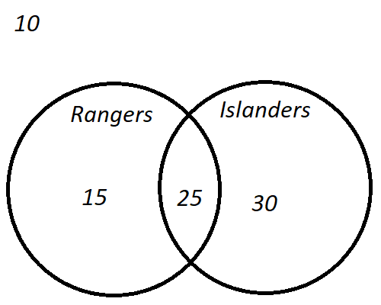

1. 200 students get to choose an ice cream cone. The can pick one flavor from three choices: chocolate, vanilla, and strawberry. They can pick one topping, either sprinkles or peanuts. The results are collected on this table.

|  |  |  |  |
| --- | --- | --- | --- |
|  | **Sprinkles** | **Peanuts** | **Total** |
| Chocolate | 40 | 50 | 90 |
| Vanilla | 25 | 5 | 30 |
| Strawberry | 65 | 15 | 80 |
| Total | 130 | 70 | 200 |

a) What is the probability that a randomly selected person chose chocolate ice cream?

b) What is the probability that a person who chose chocolate ice cream also chose peanuts?

c) What is the probability that a person who chose sprinkles also chose strawberry ice cream?

**a)**

**b) 90 people chose chocolate ice cream.  
50 people out the 90 people that chose chocolate ice cream, also chose peanuts**

**c) 130 people chose sprinkles. Out of the 130 people that chose sprinkles, 65 chose strawberry ice cream.**

1. A family has 4 children.  
   a) Make a sample space of all the boy/girl combinations; there are 16 of them.

b) What is more likely: having a 2/2 split (2 boys and 2 girls) or a 3/1 split (either 3 boys and 1 girl, or 3 girls and 1 boy)?

{BBBB, BBBG, BBGB, BBGG, BGBB, BGBG, BGGB, BGGG, GBBB, GBBG, GBGB, GBGG, GGBB, GGBG, GGGB, GGGG}

|  |  |  |
| --- | --- | --- |
| 2 boys 2 girls | 3 boys 1 girl | 3 girls 1 boy |
| 6 | 4 | 4 |

2 boys/2 girls: 6  
3 boys/1 girl: 4  
3 girls/1 boy: 4  
**3/1 split: 8, 2/2 split: 6  
A 3/1 split is more likely**

## 9.2 Calculating Probabilities Involving Independent Events

**Key Ideas**

Two events are *independent* if one happening (or not happening) has nothing to do with whether or not the other happens (or doesn’t happen). When events are not independent, they are *dependent*. It is much simpler to calculate the probability when questions that include the words “or,” “and,” and “given” involve independent events.

**Dependent Events vs. Independent Events**

Many things in the real world depend on other things. If you ask someone, “Are you going to the beach next Saturday?” that person could say, “It depends.” If you follow up with “Depends on what?” the person could respond, “On what the weather is like.” “On whether or not my friend with a car is working,” or all kinds of other possibilities.

If you ask the same person, “Is your birth day next Saturday?” he or she will not likely say, “It depends,” since there isn’t anything else that will make it more likely or less likely that the person’s birthday is next Saturday. Next Saturday will be t heir birthday or it will not, regardless, for example, of what the weather is like.

The events “person will go the beach on Saturday” and “the weather is nice on Saturday” are dependent events. The events “person’s birthday is Saturday” and “the weather is nice on Saturday” are independent events.

The table show some events and whether or not they qualify as dependent or independent when combined.

|  |  |  |
| --- | --- | --- |
| **Event A** | **Event B** | **Dependent or Independent** |
| A coin is flipped | A die is rolled | Independent |
| What happens in the Yankees baseball game | What happens in the Rangers hockey game | Independent |
| Winning the lottery | Buying an airplane | Dependent |
| Passing the Algebra II Regents | Studying this book | Dependent |
| Rooting for the Mets | The Mets winning | Probably independent, but maybe if you’re at the game and cheering really hard, it could help a little! |

**Math Facts**

It is sometimes not very clear whether two events are dependent or independent. Questions involving coin tosses, spinners, and dice are generally about independent events. For events involving human behavior, an argument can sometimes be made for either dependent or independent.

**Example 1**

Do you think these events are dependent or independent? Explain your reasoning.

Event : The groundhog sees his shadow on Groundhog’s Day.

Event : There are six more weeks of cold weather.

*Solution*: As this is an opinion question, either independent or dependent is correct as long as your reasoning is clear. For independent, you could say that the weather does not in any way know whether the groundhog saw his shadow or not. So, winter will come whenever it does, regardless. For dependent, you could say that maybe the groundhog seeing his shadow means that it is sunny on Groundhog’s Day and that the sunny day is an indication that there will come more sunny days in the future so the warm weather will come sooner.

Probability Questions Involving the Word “And”

When a coin is flipped and a 6-sided die is rolled, the outcome of the coin flip is independent of the outcome of the die roll. The coin does not know (or care, for that matter) what happened with the die.

In Section 9.1, sample spaces were used to answer probability questions involving the word “and.” With independent events, there is a shortcut for this. The shortcut is partly justified by the fact that when one fraction is multiplied by another fraction, the result will be a fraction that is smaller than either of the fractions. Likewise, the probability of two things happening is smaller than either one of them occurring individually.

When two events are independent, the probability of the first event and of the second event both happening is equal to the product of the probabilities of each happening separately.

**Math Facts**

If event A and event B are independent events, the probability of .

If is the event “the coin lands on tails,” then . If is the event “the die shows a 2,” then . (Small sample spaces, {H, T} and {1, 2, 3, 4, 5, 6} could be used to determine these probabilities. Since these are independent events, the probability that the coin lands on heads and that the die shows a 2 is . This is the same answer as was obtained in Section 9.1 with the large sample space.

**Example 2**

If the probability of Event , that it will rain in Boston on Friday, is .6 and the probability of event that the Knicks will win the game they play in Los Angeles on Friday, is .3, what is the probability that it both rains in Boston on Friday and that the Knicks win the game they play in Los Angeles on Friday?

*Solution*: These are independent events. Whether or not it trains in Boston on Friday has no impact on whether or not the Knicks win in Los Angeles on Friday. (Some people think that all things affect each other in tiny cosmic ways, even events like these. However, for the Regents, these are implied to be independent events.)

**Probability Questions Involving the Word “Or”**

For independent events, the probability of either (or both) happening can be calculated with the formula . Since the events are independent,   
. So, the formula becomes

**Math Facts**

If the events are independent, then .

**Example 3**

If the probability of event , that it will rain in Boston on Friday, is .6 and the probability of event , that the Knicks will win the game they play in Los Angeles on Friday, is .3, what is the probability that it rains in Boston on Friday or that the Knicks win the game they play in Los Angeles (or both)?

*Solution*: Since they are independent events, can be calculated with the formula .

**Probability Questions Involving the Word “Given”**

For independent events , the probability of happening is not affected by whether or not happened. So, when are independent, .

**Example 4**

If the probability of event , that it will rain in Boston on Friday, is .6 and the probability of event , that the Knicks will win the game they play in Los Angeles on Friday, is .3, what is the probability that the Knicks will win on Friday given that it will rain in Boston on Friday?

*Solution*: Since the events are independent,   
.